3. Consider the following network. With the indicated link costs, use Dijkstra’s shortest-path algorithm to compute the shortest path from x to all network nodes. Show how the algorithm works by computing a table similar to Table 4.3. 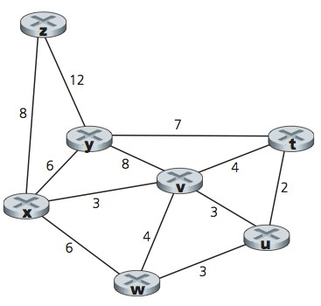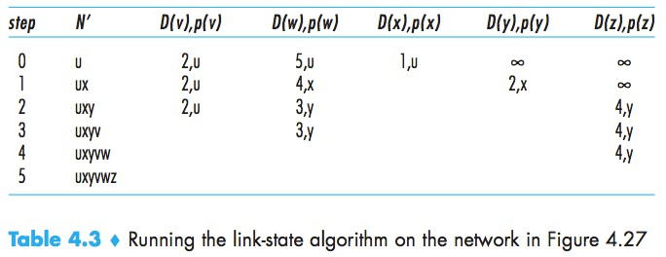

3.
Step | N’ | D(t),p(t) | D(v),p(v) | D(w),p(w) | D(y),p(y) | D(z)p(z)-+
0 | x | ∞ | ∞ | 6,x | 6,x | 8,x
1 | xv | 7,v | 6,v | 6,x | 6,x | 8,x
2 | xvu | 7,v | 6,v | 6,x | 6,x | 8,x
3 | xvuw | 7,v | 6,v | 6,x | 6,x | 8,x
4 | xvuwy | 7,v | 6,v | 6,x | 6,x | 8,x
5 | xvuwyt | 7,v | 6,v | 6,x | 6,x | 8,x
6 | xvuwytz | 7,v | 6,v | 6,x | 6,x | 8,x

4. Consider the network shown in Problem above (3). Using Dijkstra’s algorithm, and showing your work using a table similar to Table 4.3, do the following:

- Compute the shortest path from t to all network nodes.

b. Compute the shortest path from u to all network nodes. c. Compute the shortest path from v to all network nodes. d. Compute the shortest path from w to all network nodes. e. Compute the shortest path from y to all network nodes.
f. Compute the shortest path from z to all network nodes.

